

ICADE 7th: International Conference on Arts Education and Design

Preparation of Manuscript Title for ICADE: International Conference on Arts Education and Design (16 Words Maximum)

*Author1,*, Author2, Author3, Author4*

1Affiliation, Country

2Affiliation, Country

3Affiliation, Country

4Affiliation, Country

Correspondence: E-mail: emailCorresponding@ijomr.id

|  |  |  |
| --- | --- | --- |
| **A B S T R A C T** |  | **A R T I C L E I N F O** |
| Lorem Ipsum is simply dummy text of the printing and typesetting industry. Lorem Ipsum has been the industry's standard dummy text ever since the 1500s, when an unknown printer took a galley of type and scrambled it to make a type specimen book. It has survived not only five centuries, but also the leap into electronic typesetting, remaining essentially unchanged. It was popularised in the 1960s with the release of Letraset sheets containing Lorem Ipsum passages, and more recently with desktop publishing software like Aldus PageMaker including versions of Lorem Ipsum Lorem Ipsum is simply dummy text of the printing and typesetting industry. Lorem Ipsum has been the industry's standard dummy text ever since the 1500s, when an unknown printer took a galley of type and scrambled it to make a type specimen book. It has survived not only five centuries, but also the leap into electronic typesetting, remaining essentially unchanged. It was popularised in the 1960s with the release of Letraset sheets containing Lorem Ipsum passages, and more recently with desktop publishing software like Aldus PageMaker including versions of Lorem Ipsum.  © 2023 Kantor Jurnal dan Publikasi UPI |  | ***Article History:***  *Submitted/Received 00 xxx 2021*  *First Revised 00 xxx 2021*  *Accepted 00 xxx 2021*  *First Available online 00 xxx 2021*  *Publication Date 00 xxx 2021*  ____________________  ***Keyword:***  *A keyword,*  *B keyword,*  *Cc keyword.* |



**1. INTRODUCTION**

The introduction consists of the background or reasons for the research/creation, supporting theories from several literature which form a clear theoretical basis, formulation of the problem, and purpose of writing. The introduction is written in one chapter without subtitles. All exposures in the article are written in essay form, so there is no numeric and/or alphabetic format to separate chapters/sections, or to mark new chapters/sections. For this reason, if there are parts of the article that require numbering or bullet lists, make them into flowing paragraphs as follows: (1) one, (2) two, and (3) three. Note: Paragraphs 1,2,3 must use citations

Lorem ipsum dolor sit amet, consectetur adipiscing elit. Sed dapibus et neque eget congue. In ac nulla nec nunc pretium porttitor ut et augue. Duis ligula ante, eleifend ut ex sed, cursus tempus felis. Aliquam eget interdum sapien. Sed elementum varius leo, sit amet rutrum ipsum ultricies in (Westall & Brack, 2018). Aenean id mi arcu. Phasellus semper efficitur eros eu laoreet. Vivamus vitae malesuada turpis. Morbi interdum orci iaculis tempor facilisis (Khechekhouche, *et al.*, 2020; Sadasivuni, *et al.*, 2020; Yahiaoui, *et al.*, 2020; Kim, *et al.*, 2019). ed egestas mattis condimentum. Etiam et tristique turpis. Ut tincidunt velit vitae hendrerit euismod. Sed molestie volutpat orci ut placerat. Ut sit amet lorem urna. Donec luctus pharetra venenatis. Ut vel orci venenatis, tincidunt orci sit amet, pharetra ipsum. Pellentesque commodo nulla vitae ex blandit, ut sagittis turpis vestibulum (Nguyen & Juang 2013).

**2. METHODS**

The research/creation method in the article text describes the type of research/creation, subject and object of research/creation, time and location of the research/creation, research/creation instruments, method of sampling, data collection, and data analysis. In research/creation, creation in the form of products explaining the Creative Process on subjects and objects of research/creation, time and location of research/creation, research/creation instruments, methods of creation (creative process, production design, production design, etc.). Include creation process documentation, creation process infographics, creation process charts. Note: Required citation by including the research/creation method used (Quantitative, Qualitative, Descriptive, Case Study, Action Research, Design Base Learning, Research and Development etc.)

**5 Steps to Filmaking**

Stages in the filmmaking process There are several stages shown schematically in **Figure 1**.

**Development**

Sed egestas mattis condimentum. Etiam et tristique turpis. Ut tincidunt velit vitae hendrerit euismod. Sed molestie volutpat orci ut placerat. Ut sit amet lorem urna. Donec luctus pharetra venenatis. Ut vel orci venenatis, tincidunt orci sit amet, pharetra ipsum. Pellentesque commodo nulla vitae ex blandit, ut sagittis turpis vestibulum.

**Pre-Production**

Sed egestas mattis condimentum. Etiam et tristique turpis. Ut tincidunt velit vitae hendrerit euismod. Sed molestie volutpat orci ut placerat. Ut sit amet lorem urna. Donec

luctus pharetra venenatis. Ut vel orci venenatis, tincidunt orci sit amet, pharetra ipsum. Pellentesque commodo nulla vitae ex blandit, ut sagittis turpis vestibulum.

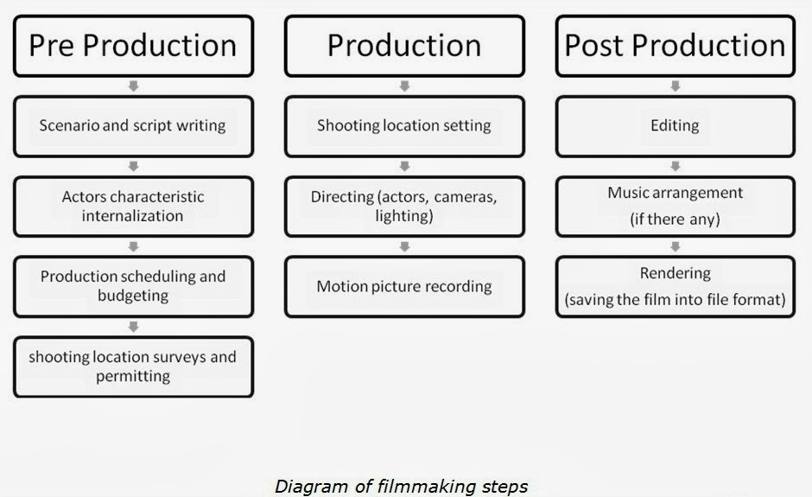

**Figure 1.** 5 Steps to Filmaking.

**Production**

Sed egestas mattis condimentum. Etiam et tristique turpis. Ut tincidunt velit vitae hendrerit euismod. Sed molestie volutpat orci ut placerat. Ut sit amet lorem urna. Donec luctus pharetra venenatis. Ut vel orci venenatis, tincidunt orci sit amet, pharetra ipsum. Pellentesque commodo nulla vitae ex blandit, ut sagittis turpis vestibulum.

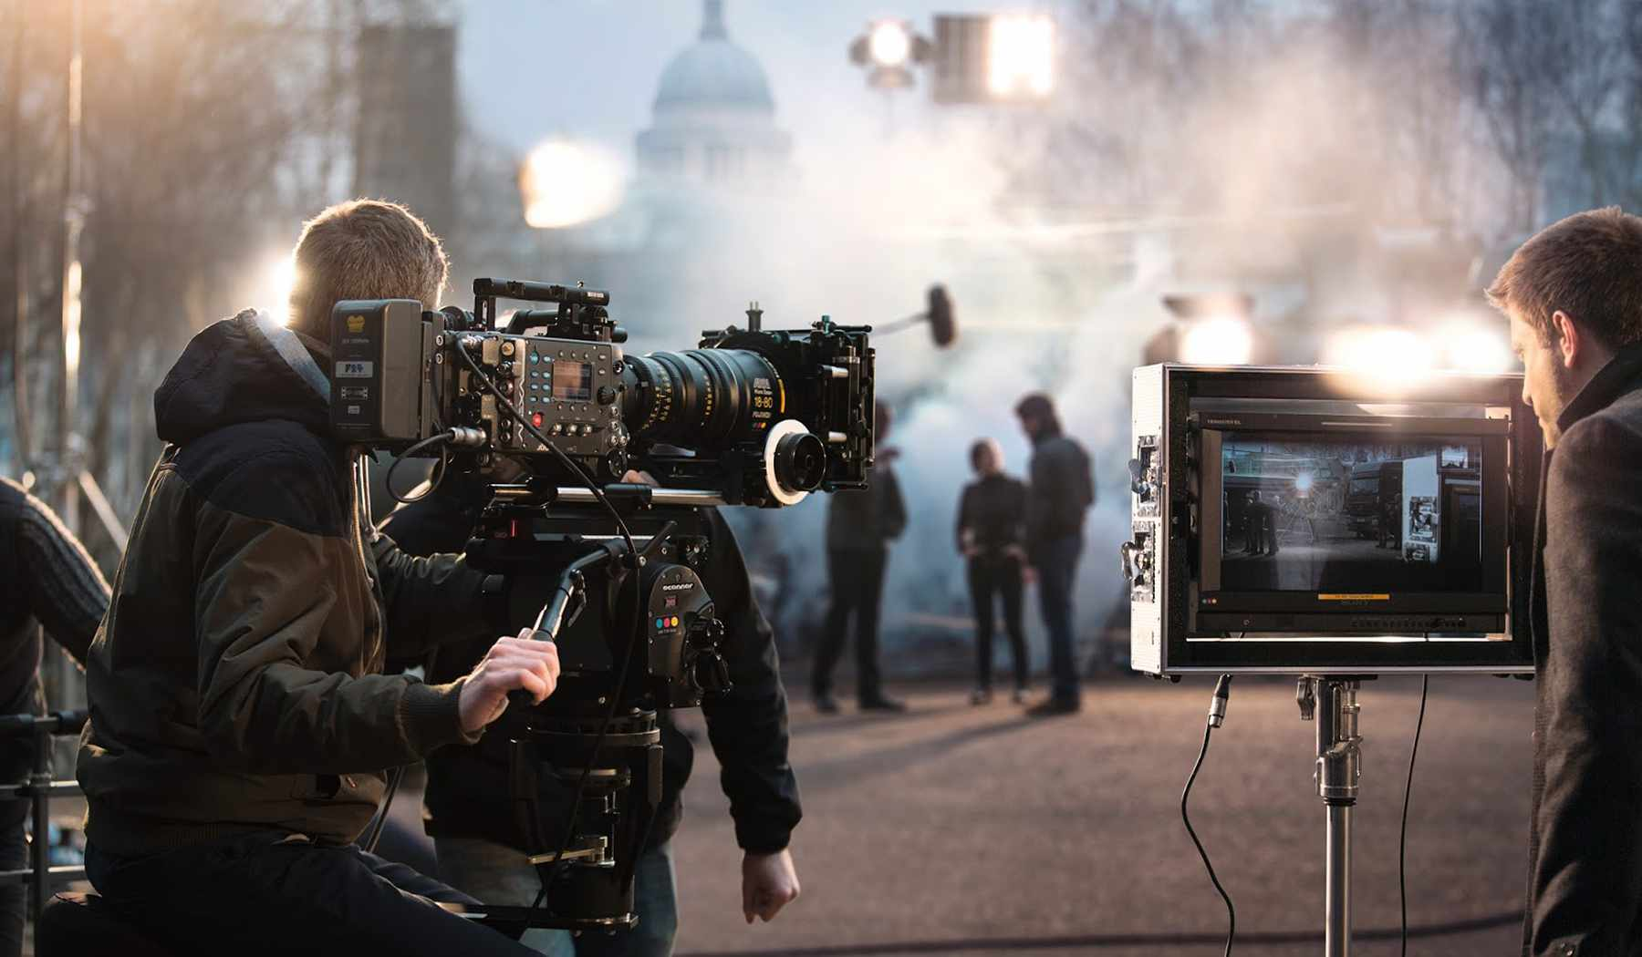

**Figure 2.** Production Process.

|  |  |
| --- | --- |
| Evolution of Video Editing: | Audio editing software - Wikipedia |
| **Figure 3.** Editing Process. | **Figure 4.** Music Editing Process. |

**3. RESULTS AND DISCUSSION**

Research/creation results describe the main findings of the research/creation. Presentations in the results and discussion are written systematically (paragraphs are made without numbering), only the results of data/information related to the purpose of the research/creation. The discussion in the research/creation article describes the results obtained from the research/creation.

The author compiles, analyzes, evaluates, interprets and compares the results of the latest findings with existing research/creation findings. This section also contains the theoretical basis/relevant concepts. The author must pay attention to the consistency of the article from the title to the bibliography.

Each quote from a reference source is cited in the text, and lists the source in the bibliography. In-text citations are written like this: (author's last name, year) example: (Supiarza, 2021) / (Undiana, 2020). While citations for online sources are written like this: (Author/editor/institution last name, year of posting) example: (Tjahjodiningrat/Student Press Unit/Indonesian Education University, 2017). Writing Sarbeni quotes (2000, 56) in Warsana (2015, 23) please avoid. Not allowed to use footnotes in the article. Avoid using subtitles in numeric and/or alphabetic formats in the results and discussion section. The entire presentation of the results and discussion in the article is written in essay form, so there is no numeric and/or alphabetical format to separate chapters/sections, or to mark new chapters/sections.

**Rating Film Analysis**

uspendisse in aliquam est, at consequat quam. Morbi porttitor orci augue. Vestibulum volutpat justo sed urna dictum, consequat condimentum nunc vestibulum. Ut nisi sem, consectetur at posuere nec, rhoncus sit amet magna. Phasellus eleifend orci dui, sit amet fringilla est malesuada non (Behera, *et al*., 2020). According to the results obtained in **Table 1** and **Figure 5**, Donec ac orci lacinia, imperdiet leo ut, blandit metus. Nam ut ante in velit fringilla luctus sit amet in purus. Vestibulum ante ipsum primis in faucibus orci luctus et ultrices posuere cubilia curae; Nam venenatis ipsum metus, eget lacinia odio gravida ac. Sed quis porttitor nisi. Nam tincidunt dapibus dui, vitae pulvinar nulla tincidunt sit amet. Nullam at mauris nulla. Aliquam ullamcorper metus eu dui auctor pulvinar. Vestibulum id ligula at lacus auctor euismod (Nolte, *et al*., 2020).

**Table 1.** description table name

|  |  |  |  |  |  |  |  |  |  |  |
| --- | --- | --- | --- | --- | --- | --- | --- | --- | --- | --- |
| **XXXXXXXXXXXXXXXXXXXXX** | | | | | | | | | | |
| **XXXX** | | **XXXX** | | **XXXX** | | **XXXX** | | | **XXXX** | |
| XXXXXXXXXXXXXXXX | XXXXXXXXXXXXXXXX | XXXXXXXXXXXXXXXX | XXXXXXXXXXXXXXXX | XXXXXXXXXXXXXXXX | XXXXXXXXXXXXXXXX | | XXXXXXXXXXXX | XXXXXXXXXXXXXXXX | XXXXXXXXXXXXXXXX | XXXXXXXXXXXXXXXX |
| 130 | 36 | 162 | 44 | 153 | 28 | | 160 | 32 | 167 | 39 |

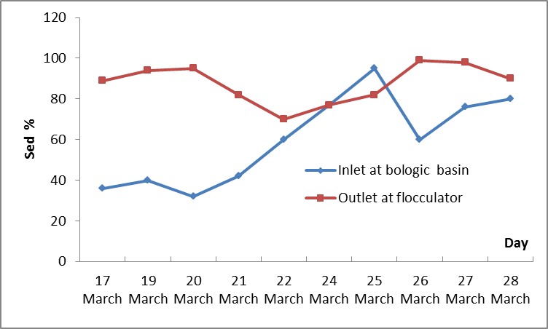

**Figure 5.** description figure name

Existing tables or figures are presented with adequate explanations and include numbers and titles. The writing of the table number and title is placed above the table, while the figure number and title is placed below the figure. Complete the existing tables and figures by writing the source under each table/figure. The table is created without a vertical border. Example table:

**4. CONCLUSION**

The contents of the conclusions should be the answers to the questions and research objectives. Conclusions are presented in one paragraph, not point-points, and not expressed in statistical sentences. Conclusions are equipped with one paragraph of research results suggestions.

**5. ACKNOWLEDGMENT**

Nulla aliquet facilisis dignissim. Integer quis justo at mauris blandit viverra id at neque. Nunc sed consectetur nisi. Praesent dictum feugiat cursus.

**6. AUTHORS’ NOTE**

The authors declare that there is no conflict of interest regarding the publication of this article. Authors confirmed that the paper was free of plagiarism.

**7. REFERENCES**

The bibliography is sorted alphabetically, without sequential numbers, and is not separated between book, online, and other sources. Authors must use the Mendeley application in compiling the bibliography. Reference sources (journals, proceedings/chapter books/mass media/.) It is not recommended to use book sources, repositories from undergraduate, masters and doctoral studies.

Khechekhouche, A., Benhaoua, B., Manokar, M., Sathyamurthy, R., and Driss, Z. (2020). Sand dunes effect on the productivity of a single slope solar distiller. *Heat and Mass Transfer*, *56*(4), 1117-1126.

Khechekhouche, A., Benhaoua, B., Driss, Z.., Attia, M. E. H., and Manokar, M. (2020 A). polluted groundwater treatment in southeastern algeria by solar distillation. *Algerian Journal of Environmental and Sciences*, *6*(1).1207-1211.

Khechekhouche, A., Bouchmel, F., Kaddour, Z., Salim, K., and Miloudi, A. (2020 C). Performance of a wastewater treatment plant in south-eastern Algeria. *International journal of Energetica*, *5*(2), 47-51.

Belbahloul, M., Abdeljalil, Z., and Abdellah, A. (2014). Comparison of the efficacy of two bioflocculants in water treatment*. International Journal of Scientific Engineering and Technology*. *3*(6), 734-737.

Behera, B., and Sethi, N. (2020). Analysis of household access to drinking water, sanitation, and waste disposal services in urban areas of Nepal. *Utilities Policy*, *62*(2020), 100996.

Heba, A., Eman, S. M. (2020). Co-sensitization of mesoporous ZnS with CdS and polyaniline for efficient photocatalytic degradation of anionic and cationic dyes. *Colloid and Interface Science Communications,* *39*(2020), 100330.

Bencheikh, I, Azoulay, K., Mabrouki, J., Hajjaji, S. E., Moufti, A., and Labjar, N. (2021). The use and the performance of chemically treated artichoke leaves for textile industrial effluents treatment. *Chemical Data Collections*, *31*(2021), 100597.

Stewart, E. J. (2012). Growing unculturable bacteria. *Journal of bacteriology*, *194*(16), 4151-4160.

Kim, Y. K., Yoo, K., Kim, M. S., Han, I., Lee, M., Kang, B. R., and Park, J. (2019). The capacity of wastewater treatment plants drives bacterial community structure and its assembly. *Scientific Reports*, *9*(1), 1-9.

Sadasivuni, K. K., Panchal, H., Awasthi, A., Israr, M., Essa, F. A., Shanmugan, S., and Khechekhouche, A. (2020). Ground water treatment using solar radiation-vaporization and condensation-techniques by solar desalination system. *International Journal of Ambient Energy*, 1-7 (*Accepted Manuscript*).